SNAP Work Requirements Screener

A plain language question set to help SNAP clients figure out if they have exemptions from the program’s work requirements

February 4, 2026

About this resource
This plain-language SNAP Work Requirements Screener helps state agencies identify when clients may qualify for exemptions. It supports consistent, accurate, and human-centered information gathering to minimize confusion and administrative burden for both clients and caseworkers. Designed with a mobile-first experience in mind, this document includes copy-ready content and screen examples that show how the questions could appear in practice.
State agencies can use the questions and design patterns from this screening questionnaire during benefits applications, renewals, or work requirements reviews. They can be added to existing application and renewal processes, or caseworkers can ask the questions directly when talking with clients. This helps collect important information early, makes eligibility conversations clearer, and makes exemption screening easier for both staff and clients.
As with any design, there is always room to improve and iterate. If you build upon this work, we’d love to hear what you learn and what works well—please feel free to reach out to us at getbenefitshelp@codeforamerica.org.

Related resources
- Interact with the questionnaire as a clickable prototype
- Read about our insights guiding our design decisions in our blog post
- Explore our Work Requirements Implementation Toolkit

Are you looking for support implementing work requirement policies? Get in touch to explore how we can work together to help your state respond to H.R. 1 mandates.

Description | Section
Check if the new SNAP work rules apply to you  It usually takes about 10 minutes to complete this form  <Fill out the form> | 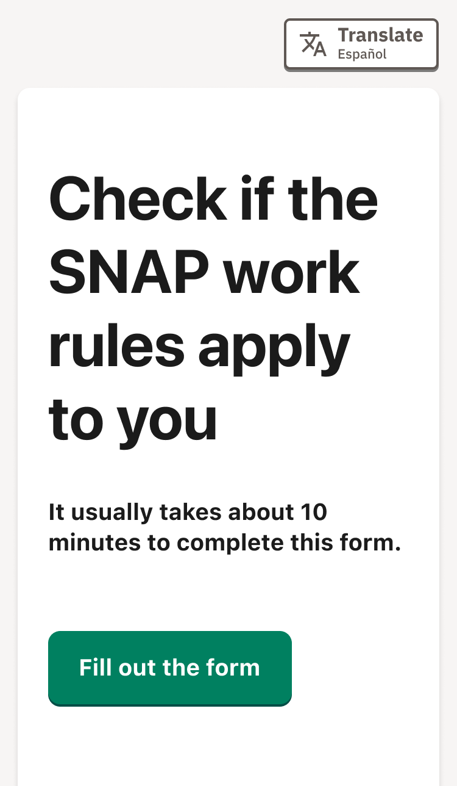
What are the SNAP work rules?  People who have to follow the SNAP work rules must do at least 80 hours of work activities a month, or, if they are working fewer than 80 hours a month, get paid at least $935.25 a month for work that they do.  Work activities include:  - Working a job for money, including self-employment or gigs  - Working in exchange for something like food, housing, or other services  - Volunteering  - Participating in job training or SNAP Employment & Training programs  If you do not do work activities for 80 hours a month, you can only get SNAP benefits for 3 months every 3 years (36 months).  If you've lost SNAP benefits because of the work rules, you can get them again by showing that you are now meeting the work rules, or that you are exempt.  Frequently asked questions.  Who has to follow the SNAP work rules?  The new law H.R.1, passed in July 2025, requires most states and counties to use the Able-Bodied Adult Without Dependents (ABAWD) work rules. It also changed the rules, so more people have to follow them. Before the new law passed, many states and counties did not have to apply these work rules.  You are considered an ABAWD and now likely need to meet the SNAP work rules if:  - You are between 18 and 64 years old, and  - You do not live with a child under 14.  Who does not need to follow the SNAP work rules?  Some people do not have to follow the SNAP work rules. You do not have to follow the SNAP work rules if you are:  - Younger than 18, or 65+ years old  - Living with a child under 14  - Pregnant  - Caring for someone who cannot fully care for themselves (for example, if they are elderly or have a disability), even if they don't live with you.  - Getting unemployment benefits, or applied for unemployment and have not been denied.  - Going to school full-time, or at least half-time.  - Getting paid at least $935.25 a month for work you do.  - Unable to work at least 20 hours a week because of a medical condition (including physical or mental health issues).  - Getting disability benefits or payments.  - In an alcohol or drug treatment program.  - An American Indian.  Will I be able to keep getting SNAP benefits?  If you do not need to follow the SNAP agency work rules, you can keep getting SNAP benefits as usual, as long as your agency knows about your exemption.  Reporting your exemption to your SNAP agency helps prevent your benefits from being cut off by accident.  If you do need to follow the SNAP work rules, you must complete 80 hours of work activities each month. Otherwise, you can only get SNAP benefits for up to 3 months every 3 years (36 months).  This form will help you figure out if you have to follow the SNAP rules or not.  What if I have a medical or mental issue that limits my ability to work?  If you can show that you can’t work for a medical or health reason, the SNAP work rules do not apply to you and you can keep getting SNAP.  If you usually have to follow the work rules but can't work for a good reason right now (for example, your car broke down, you had a family emergency, etc.), you can get excused for that month. Please contact your SNAP agency to explain that you have "good cause" for why you can't meet the SNAP work rules right now. | 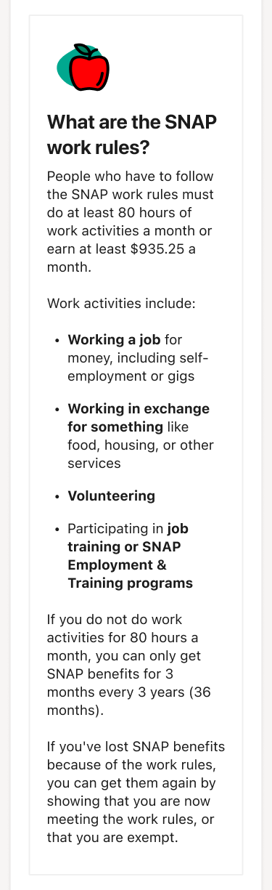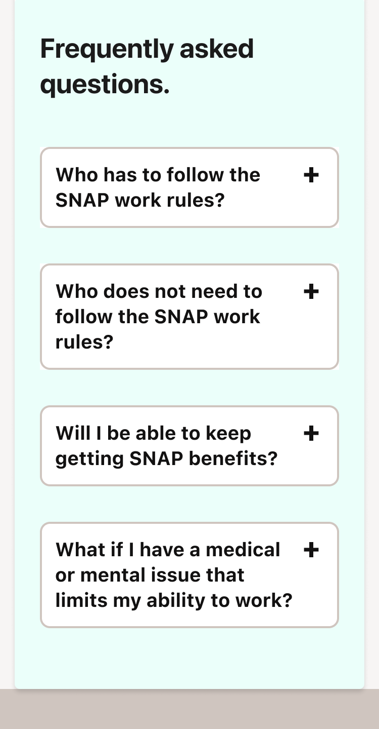  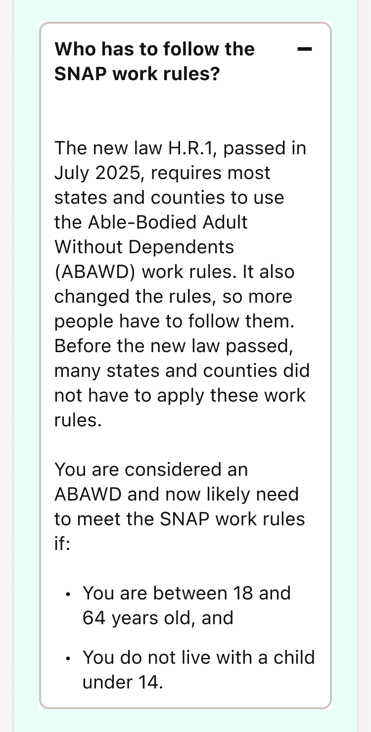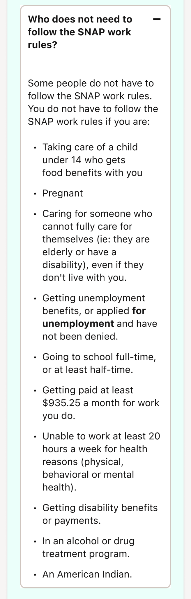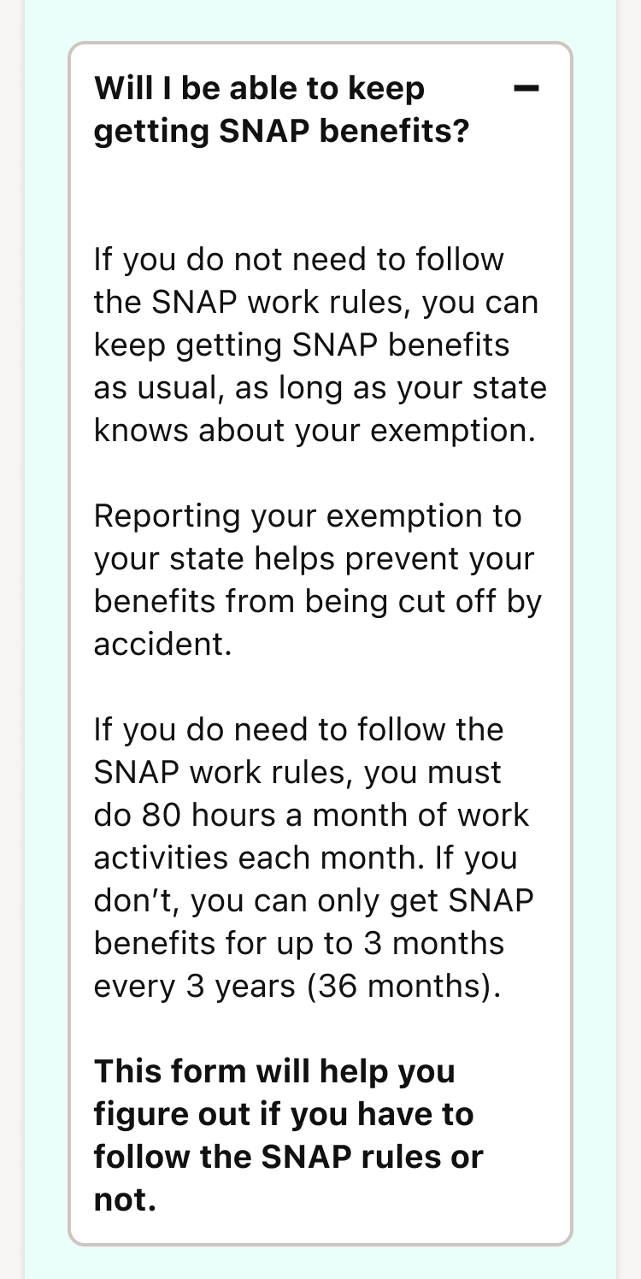  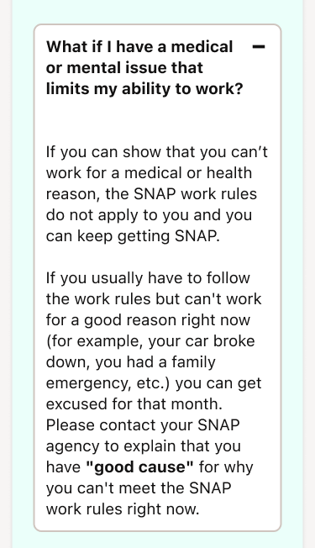
What is your date of birth? (required)  You do not have to follow the work rules if you are younger than 18, or older than 65+ years.  - Month  - Day  - Year  <Continue> | 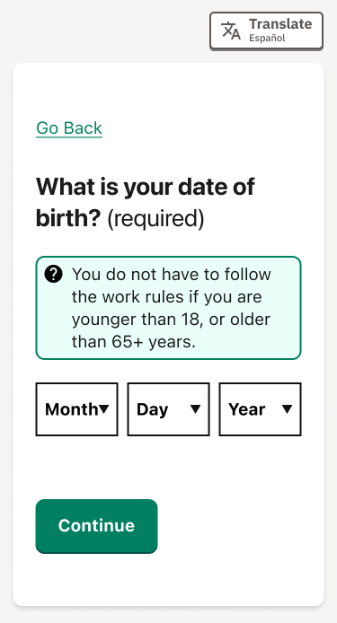

Description | Section
Are you an American Indian, or the child or grandchild of an American Indian?  Also select “Yes” if you know you are eligible for Indian Health Services.  <ü Yes> <✖ No> | 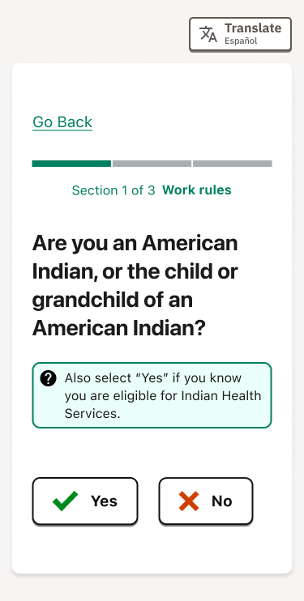
Is there a child under the age of 14 who lives in your household?  You do not have to be the child’s parent, be responsible for the child, or be their legal guardian. If you live with the child, select “Yes,” even if they aren’t included in your SNAP case.  <ü Yes> <✖ No> | 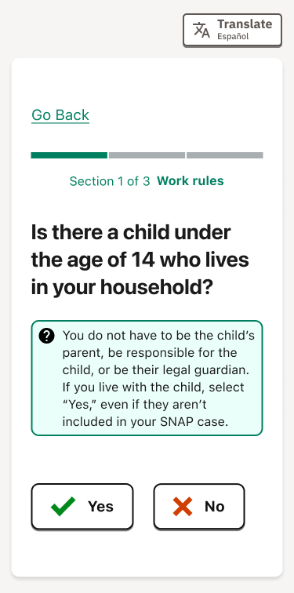
Do you care for someone who cannot care for themselves?  Caring for someone means you regularly do things like make food, help with daily tasks like bathing and personal care, run errands for them, and monitor their health and wellbeing.  The person does not need to live with you. Choose all that apply.  - Person who is ill or has a disability  - Child under age 6  - None of the above  Can you tell us about the kind of care you provide?  Providing more details can help your caseworker make a decision more quickly.  <Continue> | 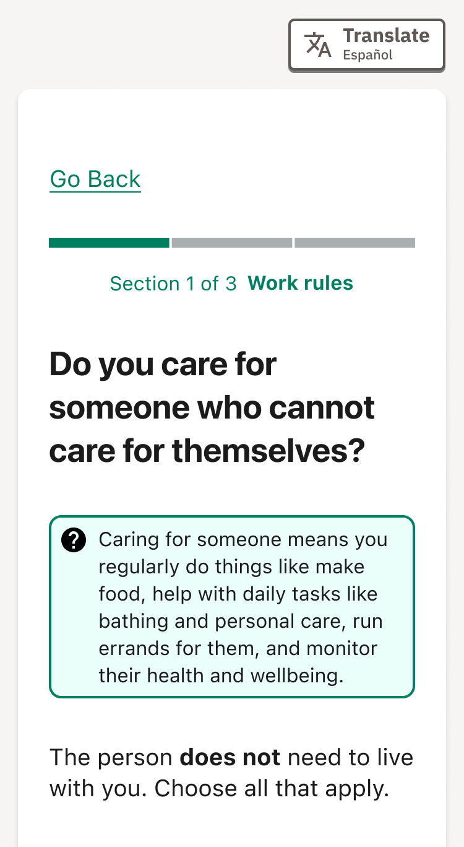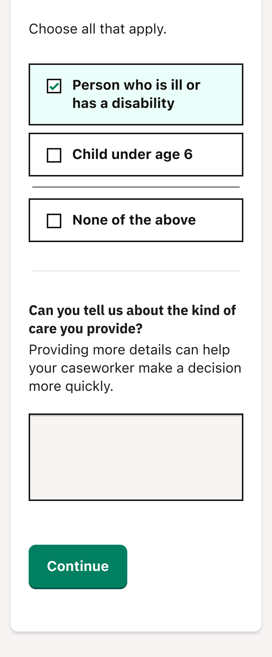
Are you pregnant?  Work requirements don’t apply to people in any stage of pregnancy.  - Yes  - No  When is the baby due?  You can estimate or skip this if you don’t know.  <Continue> | 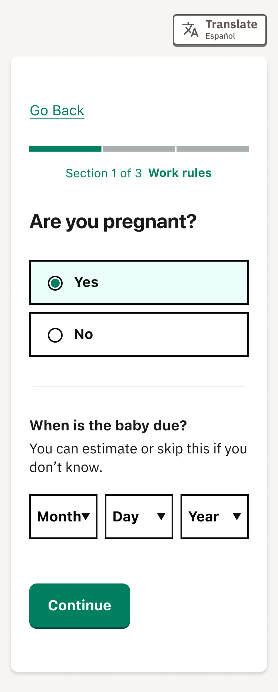
Do you get, or are you applying for unemployment benefits?  <ü Yes> <✖ No> | 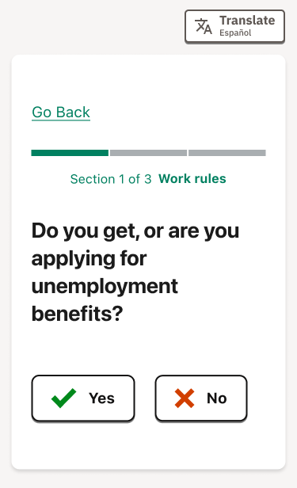
Are you receiving any of these disability benefits?  Choose all that apply.  - Social Security Disability Benefits (SSDI)  - Supplemental Security Income (SSI)  - Veteran’s disability  - Workers’ compensation  - Disability pension  - Disability insurance payments  - Disability-related Medicaid  - Other  - None of the above  If you don’t see your benefit above, please write it here.  <Continue> | 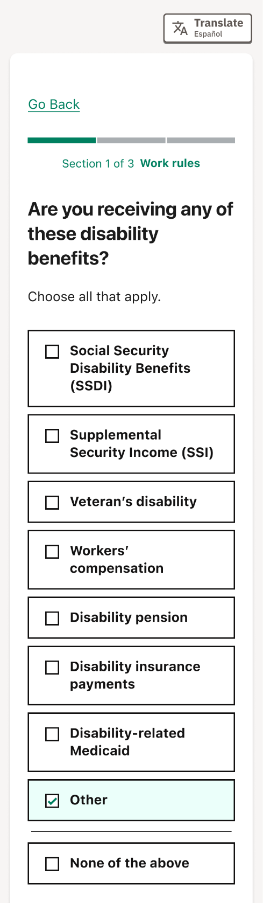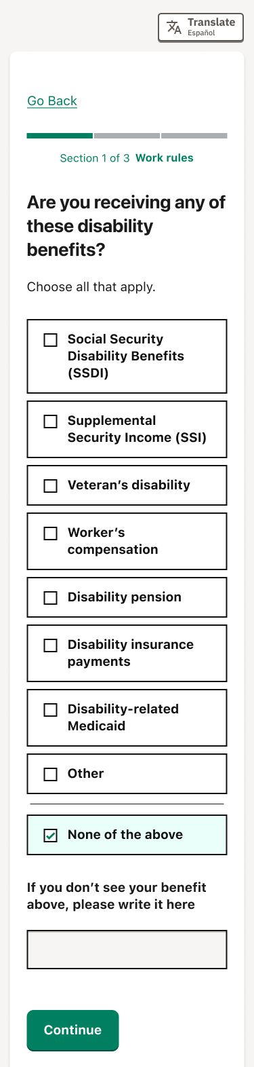
Are you working?  - Yes  - No  How many hours a week do you usually work?  If this changes, give your weekly average from the past month.  How much do you earn each week?  We know this can be hard to calculate. If you don't know the exact amount, just estimate.  <Continue> | 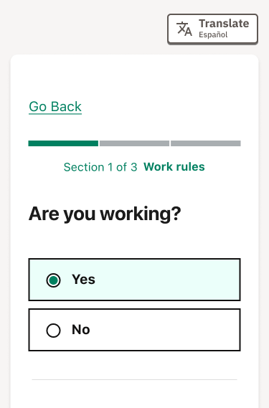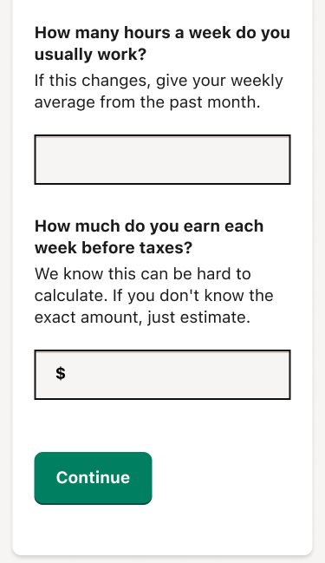
Are you a seasonal or migrant farmworker who will start a job in the next 30 days?  This means you work on a farm with a work agreement (like a contract) for part of the year, or you move from place to place for your farm work.  <ü Yes> <✖ No> | 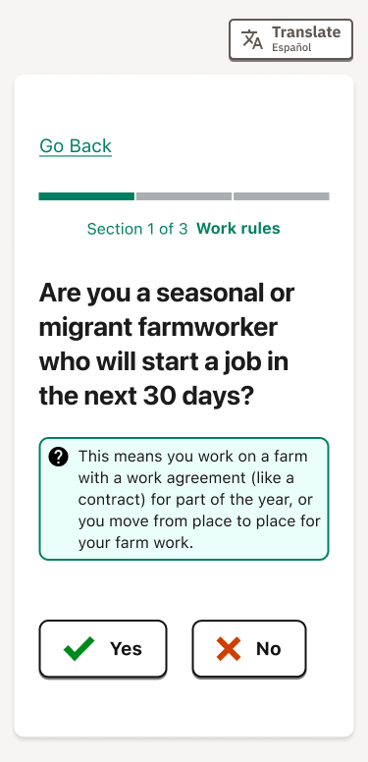
Do you volunteer or do any community service?  - Yes  - No  How many hours a week do you volunteer?  If this changes, give your weekly average from the past month.  What is the name of the organization?  If you volunteer at multiple organizations, you can list them here.  <Continue> | 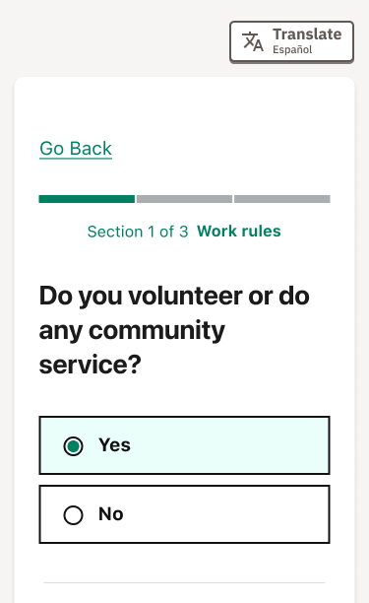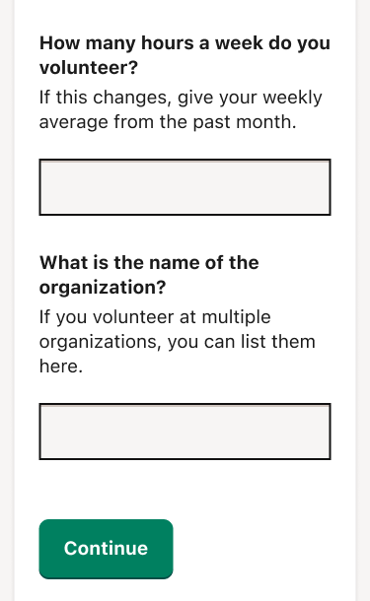
Are you in a job or work training program?  What Job Training Includes  - English as a Second Language classes  - GED classes  - Professional certificate programs  - On-the-job training  - Apprenticeships  - Job or work training program that doesn’t require a high school degree  - Programs you can get connected to through SNAP or TANF.  - Yes  - No  How many hours a week do you attend this program?  If this sometimes changes, give your weekly average from the past month.  What is the name of the organization or training program?  <Continue> | 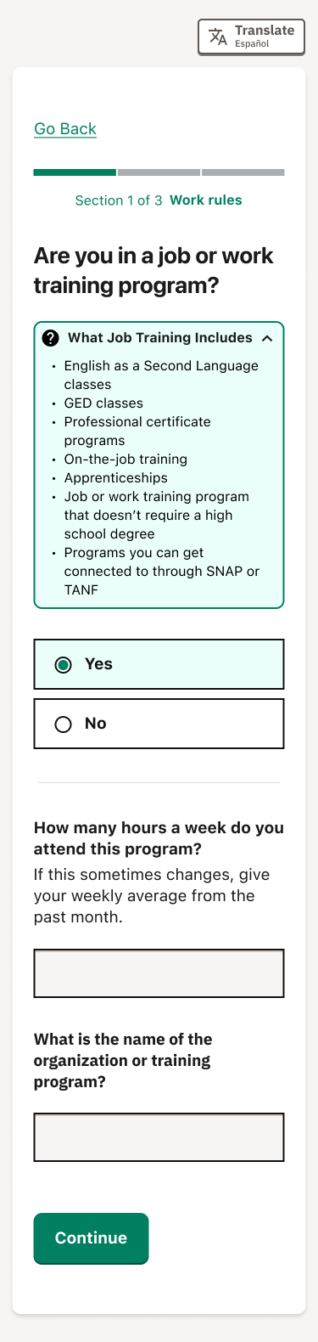
Do you go to school full-time, or at least half-time?  Your school defines what it means to be at least "half-time" based on how many classes you are taking. Ask your college, university, or school for your status.  <ü Yes> <✖ No> | 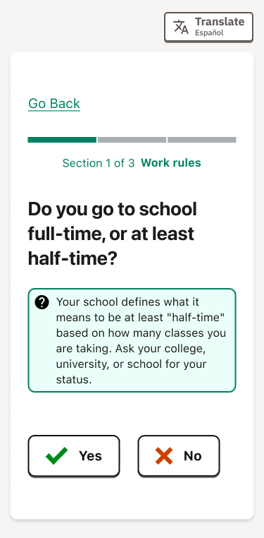
Are you in a drug or alcohol treatment program?  - Yes  - No  What is the name of the program?  This is optional.  <Continue> | 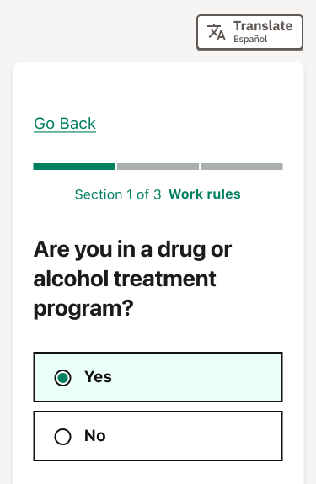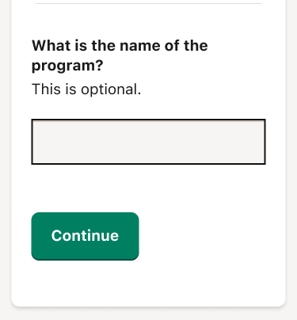

Description | Section
Situations that make it hard to work  We know these are sensitive topics. Sharing this information could help decide that you do not have to meet work rules to get SNAP benefits.  <Continue> | 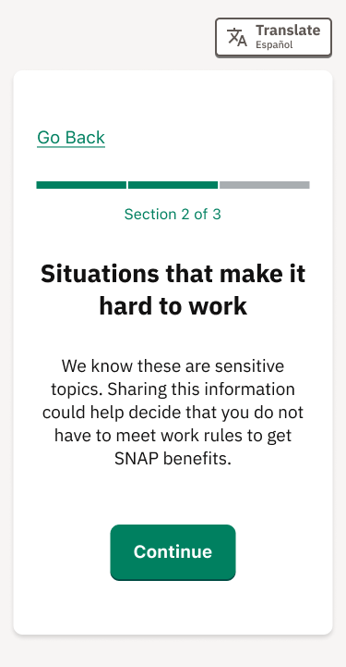
Are any of these things preventing you from working at least 20 hours a week?  Choose all that apply.  - Do not have a regular place to sleep and shower  - Struggling with drugs or alcohol  - Experiencing domestic violence  - A medical condition  This includes physical and mental health issues.  - Other  - None of the above  If you have another reason, please write it here.  <Continue> | 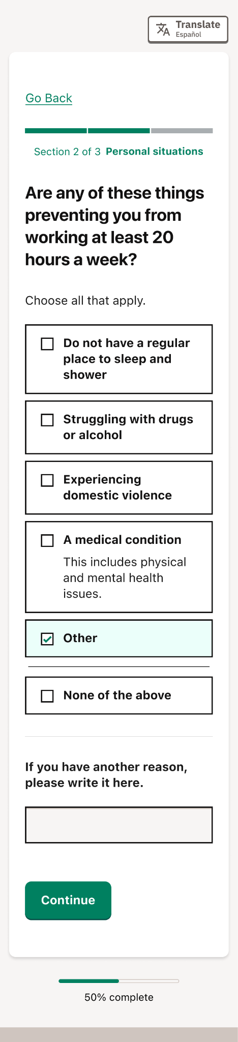
Thank you for sharing.  We’re sorry to hear things have been challenging. If you need additional help, call 211.  Can you share more information about how [this condition][these conditions] limit you from working at least 20 hours a week?  Providing more details can help your caseworker make a decision more quickly.  <Continue> | 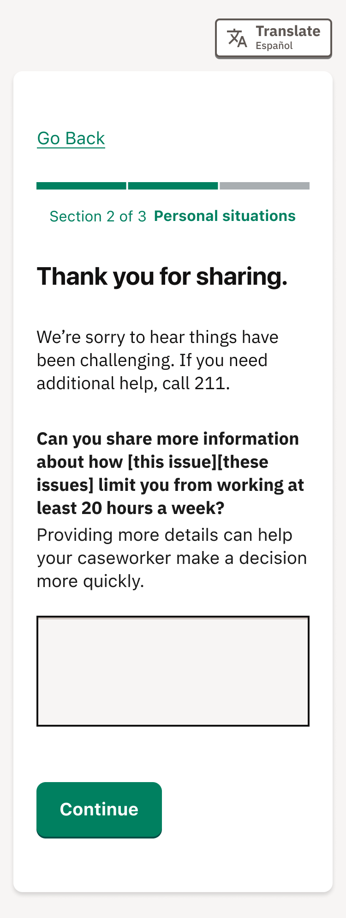

Description | Section
Get your form  This information helps your caseworker find your case when you submit your form.  <Continue> | 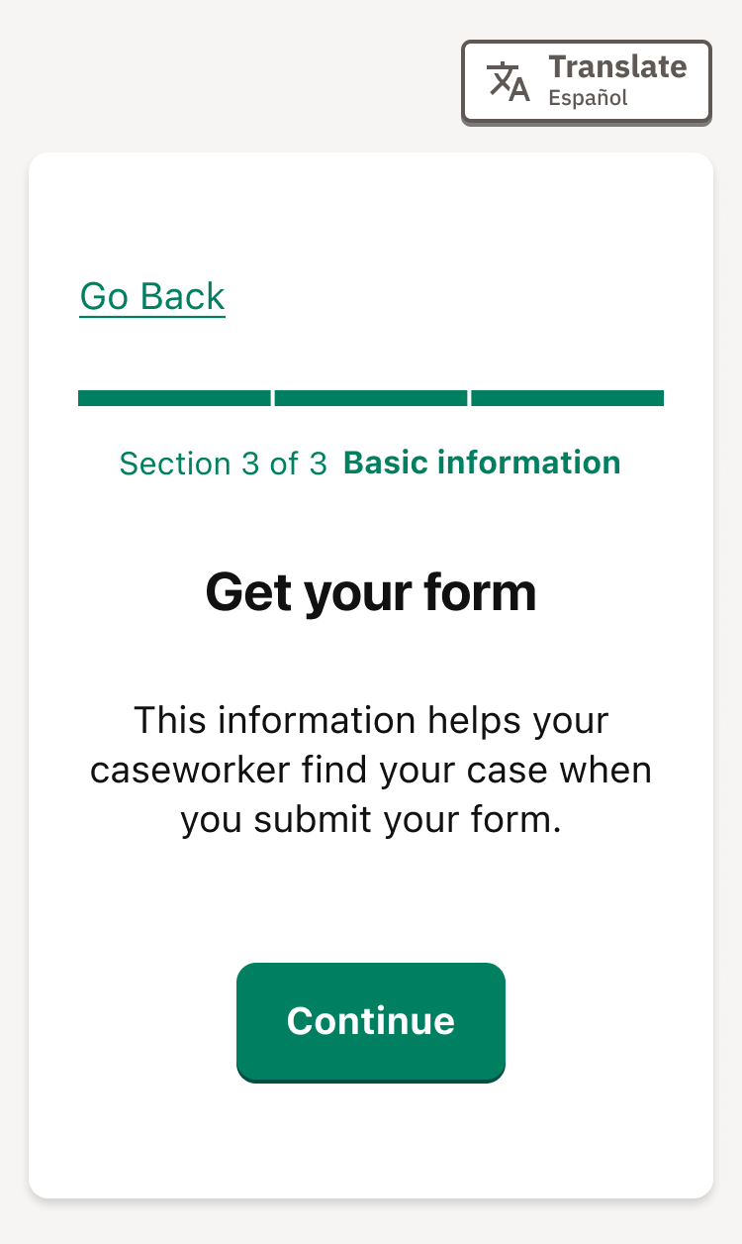
Tell us about yourself  First or given name  Legally, as it appears on your ID.  Middle name  This is optional. Legally, as it appears on your ID.  Last or family name  Legally, as it appears on your ID.  Phone number  A caseworker may use this number if they need to contact you directly about your case.  Is it okay to send you texts at the phone number you added?  This is optional. We may invite you to share feedback to help improve the form.  - Yes, you can text me  - No, don’t text me  Message frequency will vary. Message and data rates may apply. Text HELP to #### for help. Text STOP to ##### to cancel. Carriers (e.g. [carrier]) are not responsible or liable for undelivered or delayed messages. See our Terms and Conditions and Privacy Policy.  <Continue> | 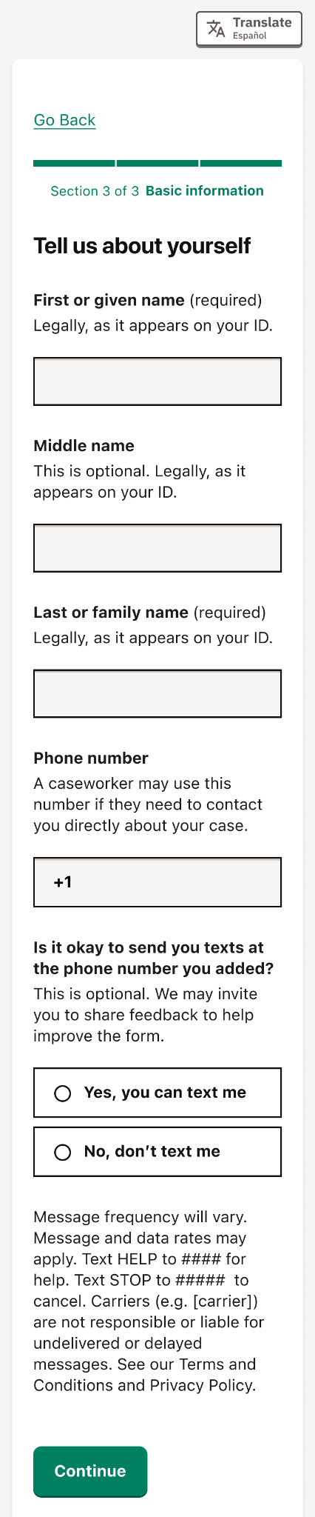
Where can we send you your results?  We’ll e-mail you next steps with your form results that you should submit to your SNAP agency.  Email  Confirm your email  <Continue> | 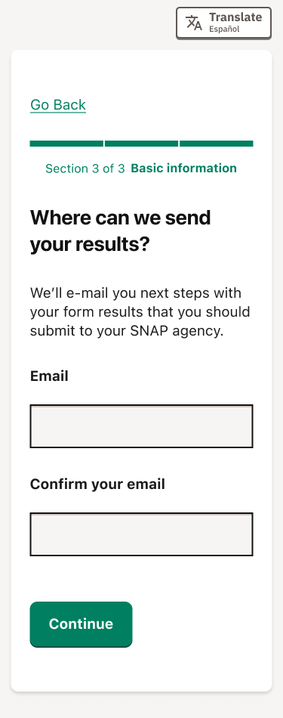
Do you have a case number?  Case number  This is optional.  <Continue>  Continue without it | 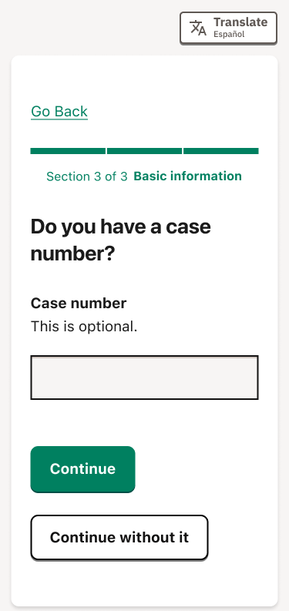
Since you don’t have a case number, would you like to provide the last four digits of your Social Security number (SSN)?  We’ll keep your information private, safe, and secure.  Social Security number  This is optional. Enter the last 4 digits to confirm your identity and find your case.  <Continue>  Continue without it | 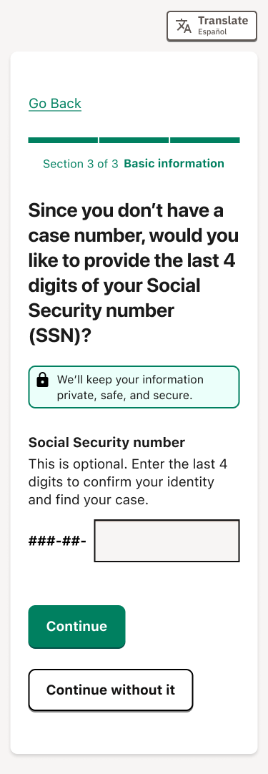

Description | Section
You may need to follow the SNAP work rules  If something changes about your situation and you cannot work at least 20 hours a week, every week, please tell your SNAP agency.  Avoid a time limit on your SNAP benefits  You can keep your SNAP benefits if your agency knows that you are doing at least one of the following things:  - Working, volunteering, or doing job training for a total of at least 20 hours a week, OR  - Earning at least $217.50 a week, OR  - Completing your required workfare hours (a volunteer job you are assigned to by your SNAP agency).  If you are not doing one of those things, you can only get SNAP for 3 months.  If you start doing one of those things and you weren’t before, send proof to your SNAP agency.  If you miss your hours in a month but you had a good reason, report it to your SNAP agency  Unexpected problems happen, like a family emergency or your car breaking down. If you have a "good cause" reason why you could not work 20 hours a week in a month, please let your SNAP agency know. If you have any documents that can help prove what happened, that can help them understand your situation.  <Continue> | 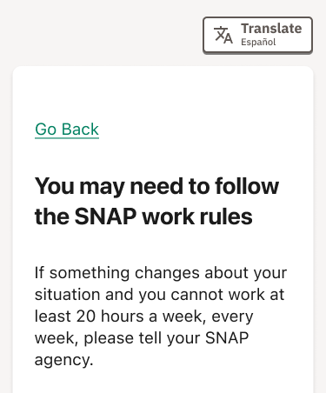  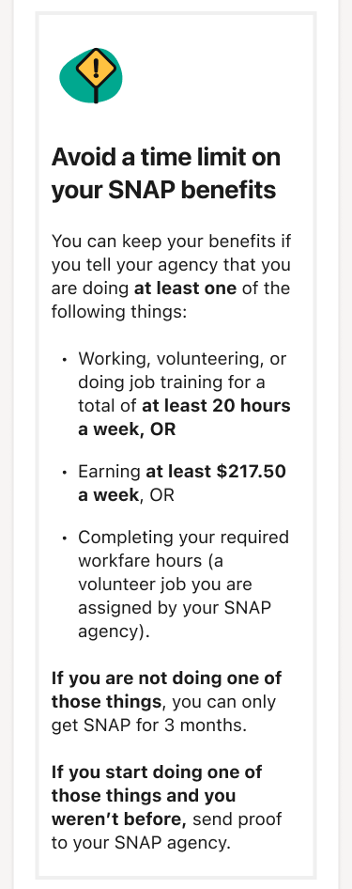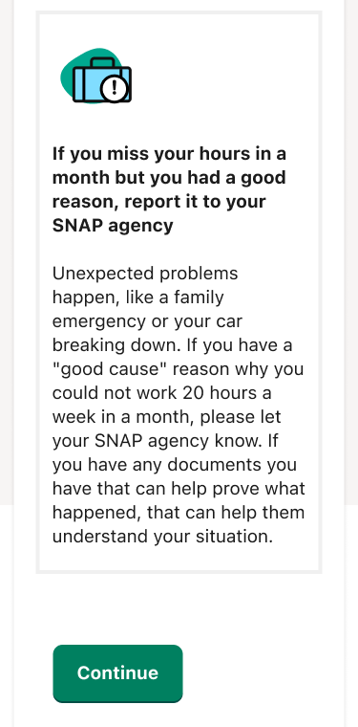

Description | Section
You may not have to follow SNAP work rules  Make sure you sign this form and give it to your SNAP agency so they can decide.  Reasons why you may not have to follow the SNAP work rules  - A member of an American Indian tribe or nation  - Living with a child under 14  - Caring for a child under 6  - Caring for an incapacitated person  - Pregnant (Due: [PREGNANT_DATE])  - Getting or applying for unemployment benefits  - Receiving disability benefits.  - Already working at least 30 hours a week  - Already earning at least $217.50 a week from work  - Reporting seasonal or migrant farmwork starting in the next 30 days.  - Going to school at least half-time  - Participating in a drug or alcohol treatment program  Reporting [a] personal situation[s] that prevent you from working 20 hours a week  - Does not have a regular place to sleep or shower.  - Experiencing domestic violence.  - Struggling with drugs or alcohol  - Has a physical or mental medical condition.  - Other  <Continue to signature> | 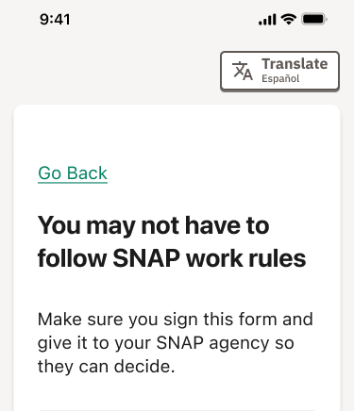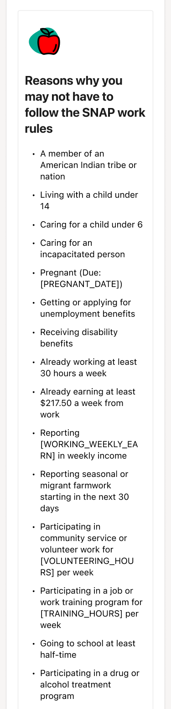  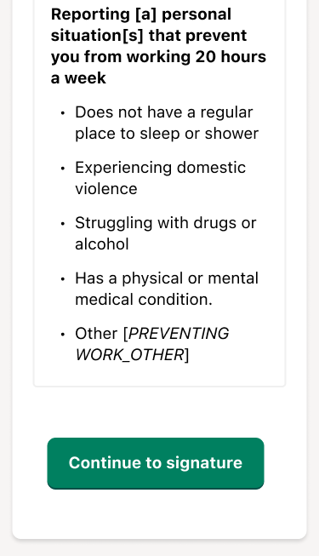
Read this before you sign your form:  [State-specific placeholder content: Legal notice.]  By signing below, I am agreeing under penalty of perjury that the information I provided in this form is true and correct.  Type your full legal name here to sign  Enter your name as it appears on your driver's license, ID, or Social Security card.  <Continue> | 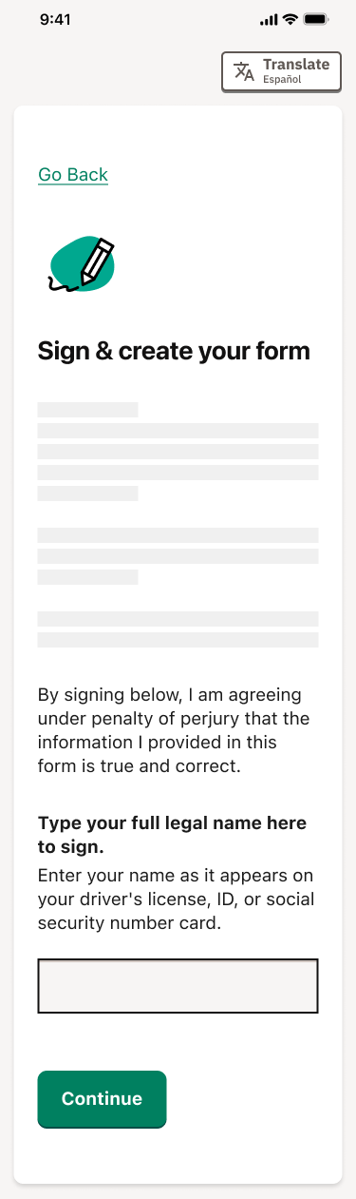
Your form was submitted  Your SNAP agency needs to review this form to decide if the work rules apply to you.  <Download form>  What to expect  - We may call you or mail you a notice if they need more information.  - In some cases, you might need to send us more or different documents that show your situation, like paystubs or proof of a medical condition, for example.  - We may not confirm receipt. We recommend checking your online account with us for more information.  <Continue> | 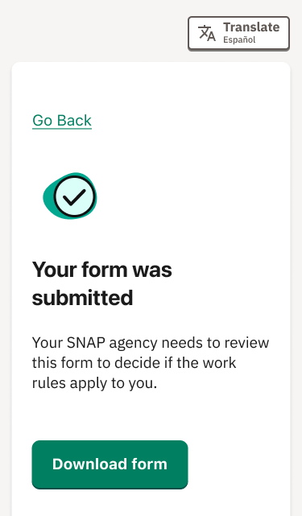  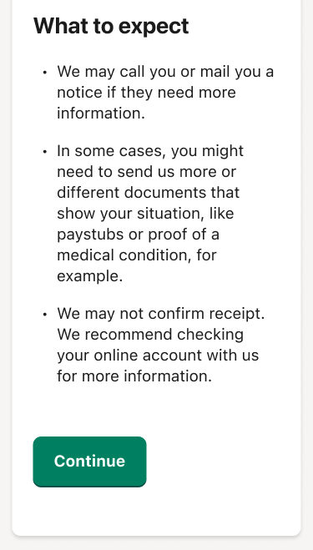
Here is the proof you may need to submit to your agency.  Does your agency already have proof of your exemptions?  - Yes, I’ve already shared that information. You can still share this information with your worker, if you think there's a chance they don't have it already.  - No, I haven’t shared that information yet. We’ll tell you what proof you may want to send below. Your [SNAP] worker will review what you share and decide if the new work rules apply to you.  Proof of working  Send in one of these verifications:  - Paystubs from the last month, OR  - A signed and dated letter from your employer with your expected hours and pay for the coming month, OR  - A signed and dated letter from your employer stating your hours and earnings for the last month (you might need this if you don’t have a paystub, for example, if you were paid in cash)  - If you’re self-employed (for example, if you do gig work, contract work, or run your own business), records showing how much you earned in the last month (such as bank statements or records from a gig work platform)  Proof of attending college, university, trade school, or high school  Financial aid papers, an enrollment letter, a transcript, or other documents showing that you’re enrolled at least half time.  If you are enrolled in school at least half time, other SNAP rules apply. In addition to your other exemptions, also tell your SNAP agency if you:  - Have a work study job, or have been approved for work study that you intend to participate in, OR  - Care for a child younger than 12, and don’t have the child care you need for you to go to school and work  - Are a single parent enrolled full-time and taking care of a child under 12  Proof of health conditions or disability  A letter from a medical or mental health provider (for example, a doctor, nurse, social worker, or other medical professional) stating that your condition makes you unable to consistently work 20 hours per week, every week  Proof of disability benefits  A letter or other document showing that you receive the disability benefits you selected:  - Social Security Disability Benefits (SSDI)  - Supplemental Security Income (SSI)  - Veteran’s disability  - Worker’s compensation  - Disability pension  - Disability insurance payments  - Disability-related Medicaid  - Other (OTHER_BENEFITS)  Proof of your treatment program  A document from your treatment center or program, stating that you regularly participate.  <Continue> | 